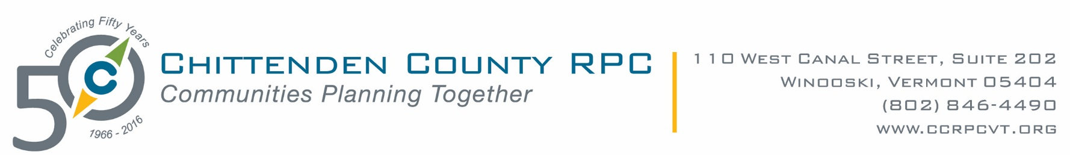

MEMORANDUM

December 2, 2016

TO:       Chittenden County Select Boards, City Councils, and Village Trustees

FROM: Charlie Baker, CCRPC Executive Director

CC:        Municipal Managers/Administrators/Clerks and Police, Rescue, & Fire Chiefs

**RE:        Regional Dispatch Implementation Study Update**

As you may recall, we updated you in September/October about this project.  In our efforts to keep all key stakeholders continually up-to-date, I would like to provide this follow-up report.

The Chittenden County Regional Dispatch Implementation study is being conducted in response to municipal budget pressures, technology changes, potential changes in state dispatching model and/or charges, and recognition that emergency services dispatching might be provided better to the public utilizing a more regionalized approach.  Since September, the consultant, DELTAWRX, has been working diligently to collect and analyze information regarding the current dispatch services in Chittenden County and evaluating the range of potential options moving forward.

Last week our consultant held a daylong workshop with the municipalities that are providing dispatch services and paying for this study:  Colchester, Milton, Essex, Shelburne, South Burlington, Williston, Burlington, Winooski, and Richmond.  There were a few key takeaways that came out of this workshop:

* The data collected and analyzed by DELTAWRX suggests that an improved regional service could be provided at cost similar to what they are today.
* In order to share the local knowledge among a regional organization, we would need for the existing dispatchers to work for the new service.  In addition to dispatchers, there are other positions that would be needed such as training and supervision that will provide dispatchers a career progression.  A regional service would be more robust and provide for better staffing daily and during major disasters.  There was a strong commitment that the existing dispatchers would continue providing this service, and it is believed that any decreases in staffing would happen through natural attrition.
* Upon review of the collected data, strong support was shown for shared governance of this service by the municipal managers and public safety chiefs in attendance.
* The most significant benefits of a Chittenden County based regional solution would include:
  + Improved service to fire companies
  + Improved support, training, and career progression potential for dispatch staff
  + Improved ability to provide 24/7/365 coverage with adequate staffing
  + A more efficient delivery of this vital service

This is still very much a work in progress.  The consultant will be drafting the report over the next 60 days.  If you would like to see more detail such as, project materials, meeting agendas and minutes, please see <http://www.ccrpcvt.org/our-work/emergency-management/regional-dispatch/>.

There is enough interest and energy at this point to believe that the effort to implement some form of regionalized dispatch will continue through 2017 and into FY2018.  Although we don’t have a firm scope of work yet, and won’t have the consultant’s report until February, we are expecting that there will be significant work required in the next year to engage with each municipal elected body and the fire, rescue, and police organizations to continue the implementation work.  The specific scope of this work will be confirmed in early 2017 with your input. We are estimating that it will take about $50,000 to do this work next year.  Each municipality received a request to include funds in your FY2018 budget from me last week.

We promise to keep you abreast every step of the way and will be scheduling a meeting with your Council, Selectboard, or Trustees in early 2017 after we receive the report and its recommendations.  If you have questions, please do not hesitate to contact me or Lee Krohn ([lkrohn@ccrpcvt.org](mailto:lkrohn@ccrpcvt.org) or 846-4490 x30).

*Charlie Baker*

*Executive Director*

*Chittenden County Regional Planning Commission*

*110 West Canal Street, Suite 202*

*Winooski, VT 05404*

*(802) 846-4490 ext. *23*

*Direct line (802) 861-0115*

*Cell (802) 735-3500*

[*www.ccrpcvt.org*](http://www.ccrpcvt.org)

*[CCRPC-50th-Logo-Email](http://www.ccrpcvt.org/)*